**Network Task**

1. Get the IP address of a particular domain (guvi.in).

nslookup guvi.in

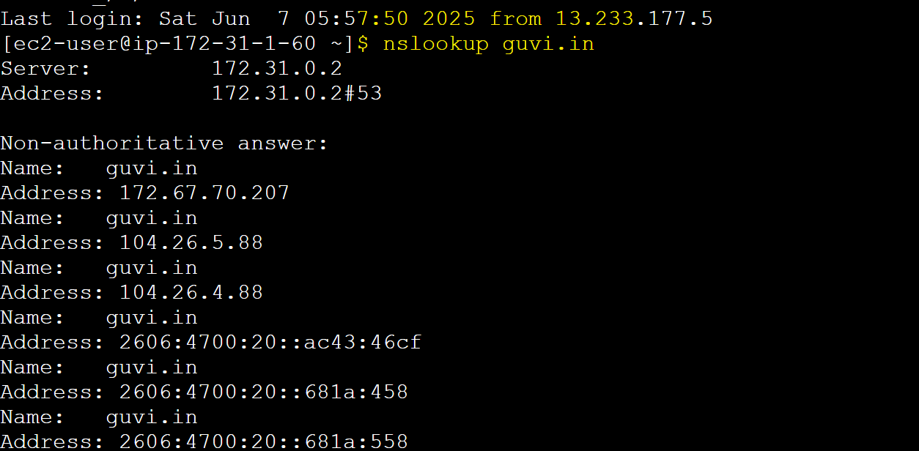

find the CPU/memory usage of my server

vmstat



Test the connectivity between 2 nodes

ping guvi.in

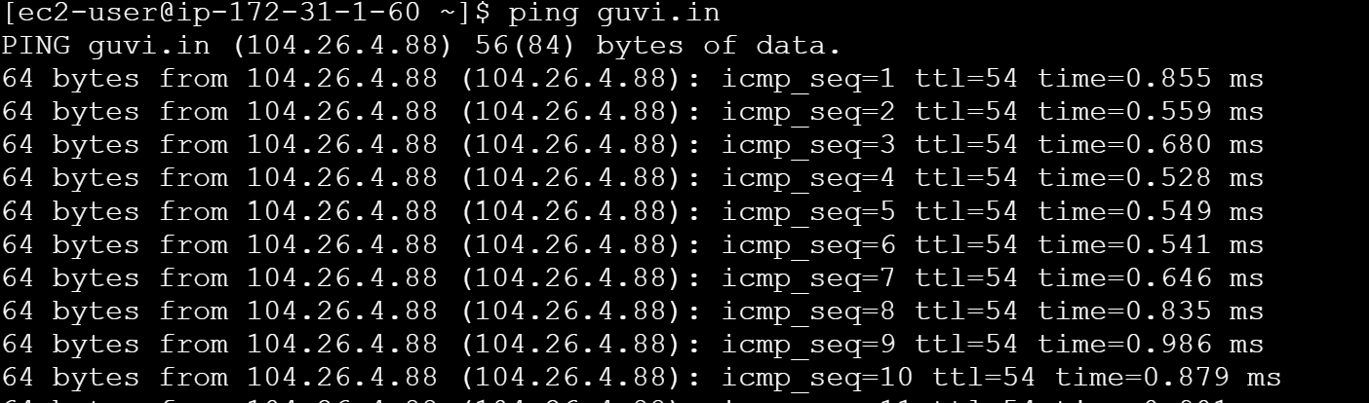

2. To Check port is open or not

Enabled Telnet in Linux and tried

Unable to connect to port 9000

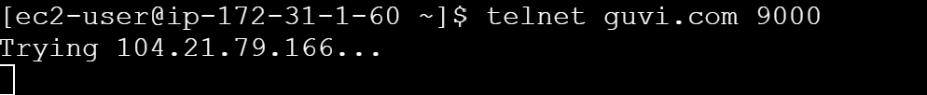

Able to connect port 80 and 443

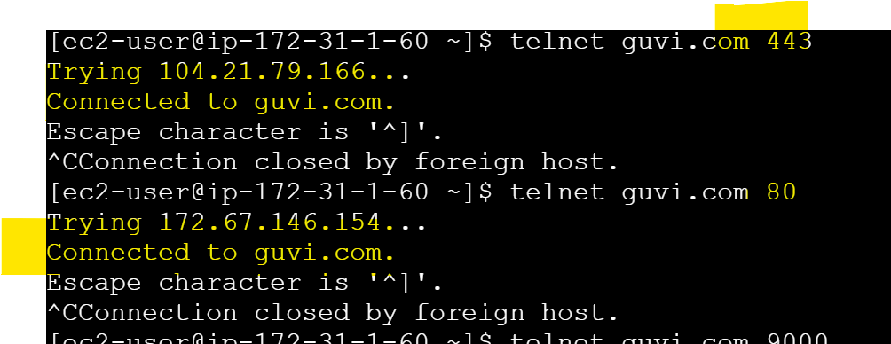

Enabled nmap in linux

Port 9000 is not open to access

